ORANGE BELT & ABOVE ADVANCED SPARRING EQUIPMENT

All AIM students who are advancing through the ranks are experiencing more contact during sparring activities. In order for your child to maintain the highest level of protection AIM highly recommends this advanced sparring equipment for all Orange Belts & above. As always AIM is determent to bring you the lowest prices direct from the wholesaler. Tax in included in all AIM prices.

BLACK UNIFORM W/LOGO BLACK HEAD GEAR
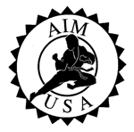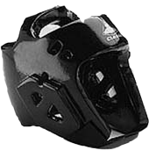
Official AIM USA Uniform available to Orange belts & above only.
Sizes: 1, 2, 3, 4, 5, 6, and 7.
Offers extra protection in case of accidental contact during sparring.
Sizes: S, M/L, and XL.

Retail Value: | $ 40.00 | Retail Value: | $36.00
AIM Price: | $ 35.00 | AIM Price: | $25.00
Save: | $ 5.00 | Save: | $ 11.00

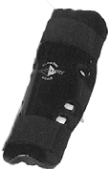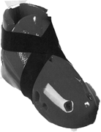BLACK FOOT PADS BLACK SHIN/FOREARM PADS

Full foot coverage from ankle to toe. This lightweight foot pad features toe ties & a reinforced bottom strap to aid in traction.
Can be used as shin pad and or forearm pad. Lightweight and comfortable fit.

Retail Value: | $ 30.00 | Retail Value: | $ 27.00
AIM Price: | $ 22.00 | AIM Price: | $ 22.00
Save: | $ 8.00 | Save: | $ 5.00

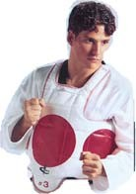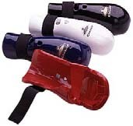BLACK HAND PADS SPARRING VEST (REQUIRED)
Contoured to fit and cover the entire hand comfortably. This lightweight glove has full finger coverage.
Lightweight & comfortable design offers complete upper body protection. Reversible feature, red scoring zone on one side and blue on the other.

Retail Value: | $ 30.00 | Retail Value: | $ 50.00
AIM Price: | $ 22.00 | AIM Price: | $ 40.00
Save: | $ 8.00 | Save: | $ 10.00

DISCLAIMER
This sparring equipment is designed to provide a margin of safety in case of accidental excessive contact. Manufacture recommends a complete set of safety equipment to be worn at all times by both competitors, including foot, shin, hand, forearm, chest, headgear, mouthpiece and groin protection. User assumes all risks of injury.

Voice 804-323-5985 Fax 804-323-5941 E-Mail AIMUSAINC@AOL.COM Web www.aimusainc.com

